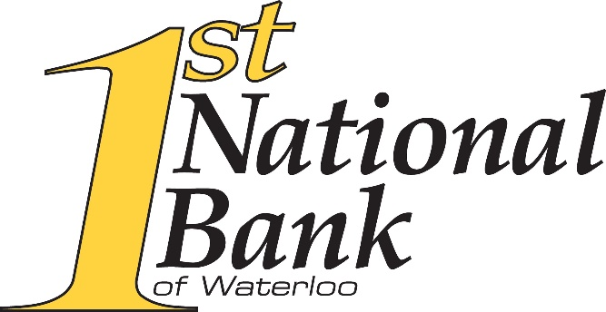
PRESS RELEASE
For more information, contact:
First National Bank of Waterloo
Rick R. Parks
President and CEO
228 South Main Street
PO Box 507 Waterloo, IL 62298
(618) 939-6194 ext. 1112
rparks@fnbwaterloo.bank

First National Bank of Waterloo Completes Acquisition of The Village Bank
WATERLOO, IL -- First National Bank of Waterloo is pleased to announce that its parent company, First Waterloo Bancshares, Inc., Waterloo, Illinois, has acquired the outstanding shares of common stock of Village Bancshares, Inc., St. Libory, Illinois. The transaction closed on November 30, 2022.
“The Village Bank is a strong strategic and cultural fit for us and I am truly excited about the positive impact our combined company will have in the St. Libory, New Athens, and Marissa communities. Together, we have the capabilities and scale with a community-based model to help us better serve new and existing customers, businesses, and communities. We believe that we are stronger together,” said Rick Parks, President, and CEO of First National Bank of Waterloo.
The partnering of First National Bank of Waterloo and The Village Bank is expected to:
- Provide greater lending capacity
- Expand banking products and services
- Expand support to service area communities
- Offer added career opportunities for employees
- Continue building value for shareholders
First National Bank of Waterloo currently has thirteen banking centers in central and southern Illinois, serving customers in Waterloo, Columbia, Millstadt, O’Fallon, Effingham, Stewardson, Dupo, Smithton, Collinsville, Maryville, and Swansea. The Village Bank has three banking centers in St. Clair County and is serving customers in St. Libory, Marissa, and New Athens.
Bryan Cave Leighton Paisner, LLP served as legal counsel to First Waterloo Bancshares, Inc. Armstrong Teasdale, LLP served as legal counsel to Village Bancshares, Inc.

